Experiment 3
Capturing and Analyzing Network Packets

Lab 3 Objectives:
● Understand the structure and functioning of the OSI and TCP/IP models.
Prerequisites: The prerequisites of this lab are-
● Basic understanding of computer networks and communication protocols.
● Familiarity with OSI and TCP/IP models.
● Experience with network monitoring tools such as Wireshark.

Outcomes: By the end of this lab, students will be able to:
● Capture and interpret network packets using Wireshark.
● Analyze how different protocols map to OSI and TCP/IP layers.
● Understand the flow of network traffic and troubleshoot network-related issues.

Description: In this experiment, students will use Wireshark, a network protocol analyzer, to capture real-time network packets and analyze their contents to understand how data flows through the OSI and TCP/IP models.

Part 1: Understanding OSI and TCP/IP Layers
OSI Model
The OSI (Open Systems Interconnection) model is a conceptual framework used to understand and design networks. It divides network communication into 7 layers, each with specific functions:
- Physical Layer: Deals with the physical connection between devices, including cables and signals.
- Data Link Layer: Handles error detection and frames data for transmission between adjacent nodes.
- Network Layer: Manages logical addressing and routing of data packets.
- Transport Layer: Ensures reliable data transfer with flow control and error recovery.
- Session Layer: Manages sessions or connections between applications.
- Presentation Layer: Translates data formats and handles encryption/decryption.
- Application Layer: Interfaces directly with user applications and provides network services (e.g., HTTP, FTP).

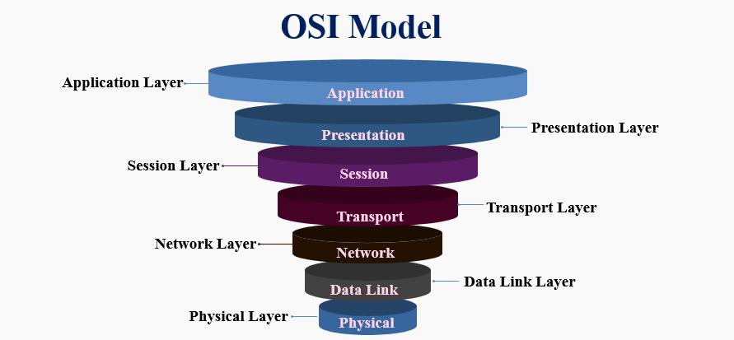

TCP/IP Model
The TCP/IP model is a practical, simplified model used in real-world networks and the internet. It has 4 layers:
- Network Interface Layer: Combines OSI’s Physical and Data Link layers, managing hardware addressing and transmission.
- Internet Layer: Handles logical addressing and routing using the IP protocol.
- Transport Layer: Provides end-to-end communication with protocols like TCP (reliable) and UDP (unreliable).
- Application Layer: Supports network services and applications such as HTTP, FTP, SMTP, and DNS.
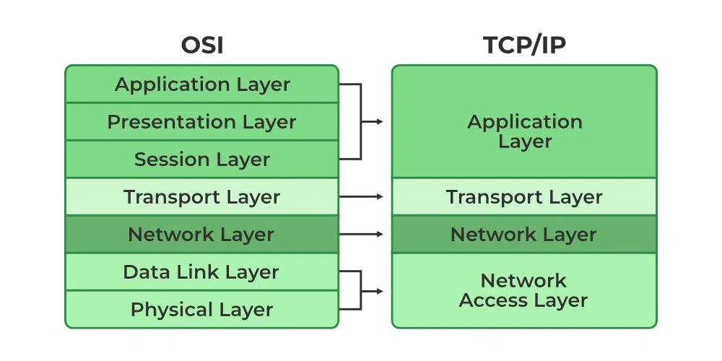

Protocols Analyzed in Packet Capture
When capturing network traffic using tools like Wireshark, the following protocols are commonly analyzed to understand network communication:
- HTTP (Hypertext Transfer Protocol): Used for web browsing (Application Layer).
- TCP (Transmission Control Protocol): Ensures reliable, ordered data transfer (Transport Layer).
- UDP (User Datagram Protocol): Provides faster but connectionless data transfer (Transport Layer).
- IP (Internet Protocol): Routes data packets between devices (Internet Layer).
- ARP (Address Resolution Protocol): Resolves IP addresses to MAC addresses (Network/Data Link Layer).
- ICMP (Internet Control Message Protocol): Used for diagnostic tools like ping (Internet Layer).

Capturing Network Packets Using Wireshark
When Wireshark is opened, it displays a list of active network interfaces. In my case, my laptop was connected via Wi-Fi, so I selected the Wi-Fi interface.
Image
The active network interfaces are shown in Wireshark, including my Wi-Fi connection.
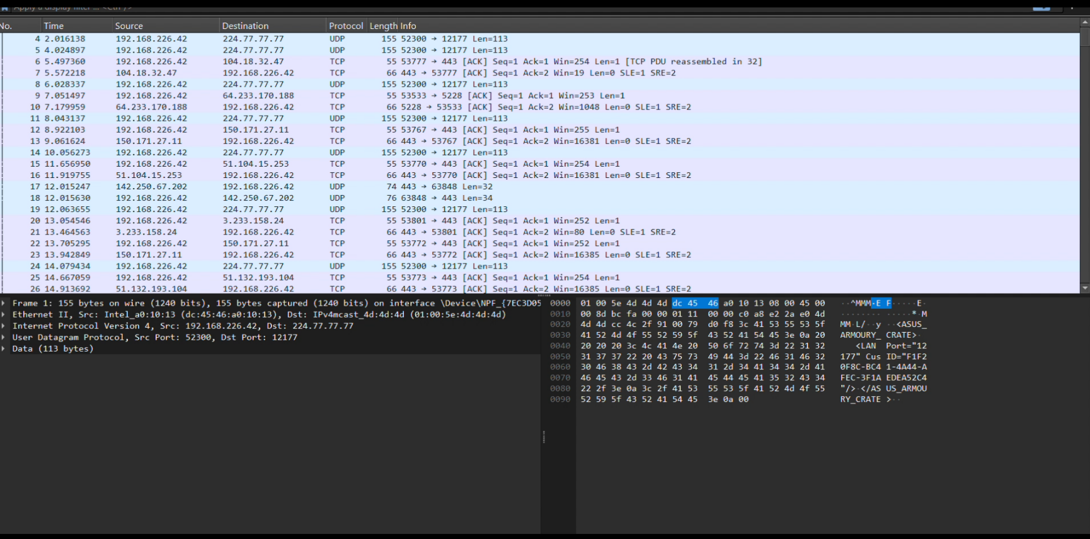

Image 2:
Wireshark is capturing live network packets, showing packets from different protocols.
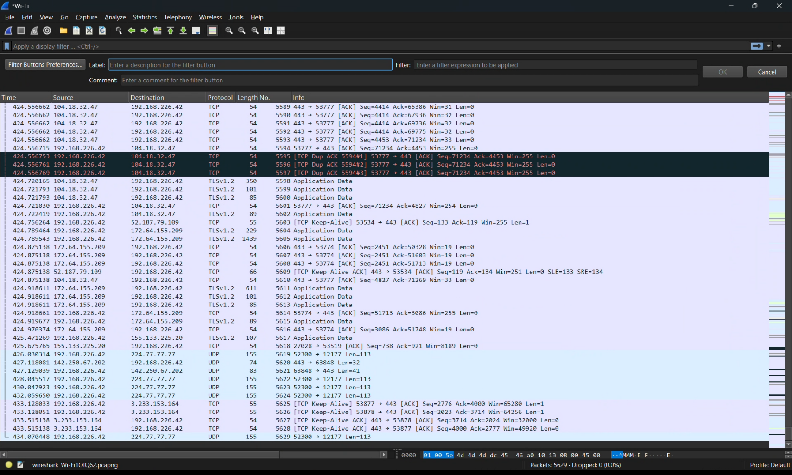

Analyzing Captured Packets in Wireshark
Filtering Packets
Wireshark provides a filter bar at the top, allowing users to filter packets by specific protocols. Common filters include:
- http — Displays HTTP traffic
- tcp — Shows TCP segments
- udp — Shows UDP packets
- icmp — Displays ping requests and replies
By typing the protocol name and pressing Enter, only packets related to that protocol are displayed.

Examining Packet Details
Clicking on any packet reveals detailed information below, including the source and destination IP addresses, port numbers, and protocol headers such as TCP, IP, and HTTP. This helps understand how data traverses through the OSI model layers: Application → Transport → Network.

TCP Three-Way Handshake
The TCP connection is established through a three-step process known as the three-way handshake:
- SYN: Client sends a connection request
- SYN-ACK: Server acknowledges the request
- ACK: Client confirms the connection
Filters to identify these packets in Wireshark are:
- tcp.flags.syn == 1 and tcp.flags.ack == 0 — SYN packets
- tcp.flags.syn == 1 and tcp.flags.ack == 1 — SYN-ACK packets
- tcp.flags.ack == 1 and tcp.flags.syn == 0 — ACK packets

Image
Wireshark screenshot displaying the TCP three-way handshake with SYN, SYN-ACK, and ACK packets.
